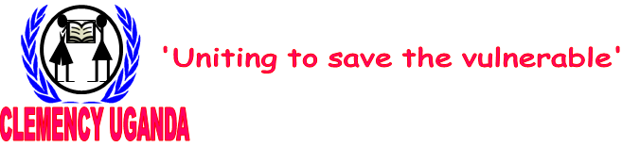

P.O.Box 291, Jinja, Uganda (E.A)
Telephone: +256-454-448-192
Mobile: +256-712-083-457 OR +256-773-663-516
Email: sponsorship@clemency-uganda.org

CHILD SPONSORSHIP FORM
Clemency Uganda sponsorship scheme has dramatically improved the lives of children in Jinja. You too can wipe a child’s tears by bringing hope.
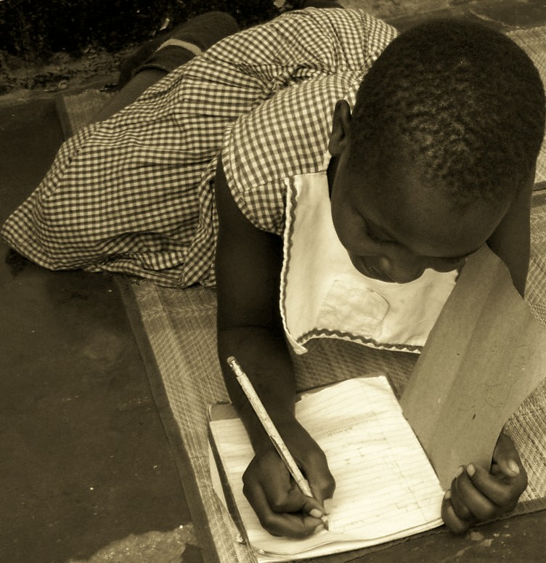
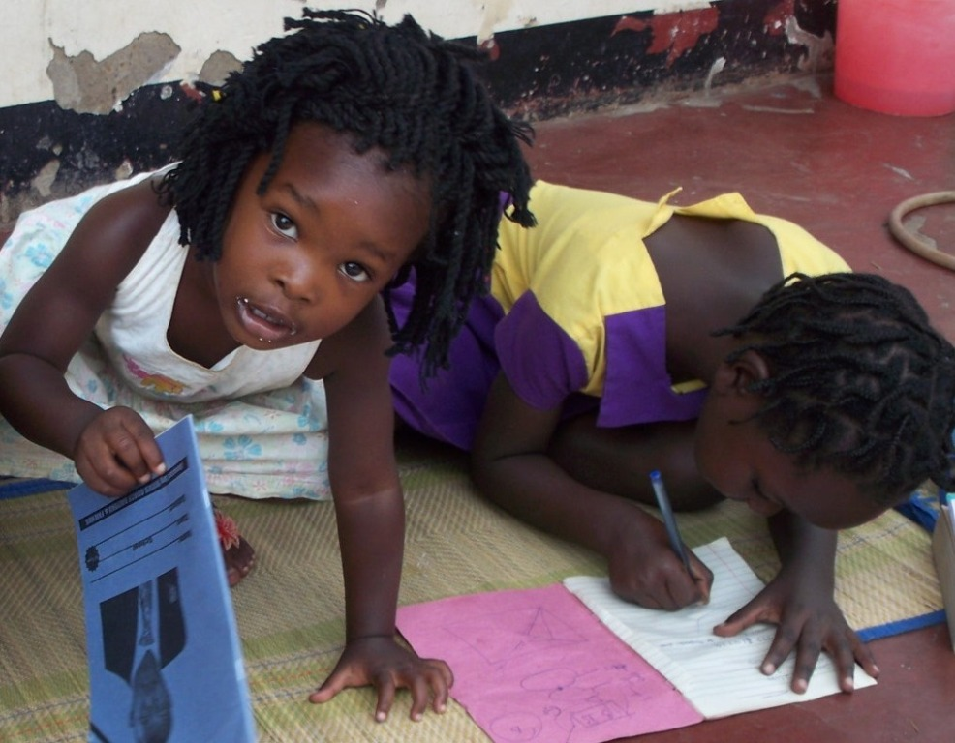

Why sponsor a child under Clemency Uganda?
In a poor country like Uganda where government schools are woefully equipped, have inadequate teaching space, classrooms, desks, chairs and text books and no teaching aids or displays, overcrowded, understaffed and charge additional fees (teachers’ lunch, breakfast, uniforms etc). Yet school fees is one of the biggest obstacles to the expansion of schooling in Uganda where poverty has imposed tough choices on families and households about how many children to send to school, which children to send to school, and how long they may attend, many children are unable to afford school since their parents and guardians cannot afford footing costs associated with schooling. Clemency Uganda Child Sponsorship gives you the opportunity to; rescue a child from severe poverty; give them an opportunity to go to school for better future; receive school fees, school uniform, scholastic materials; break the bitter cycle of poverty and dependency, and provide a way to lead a meaningful life that will in turn benefit their whole society.
How does it work?
We request you to sponsor a child so that we can support a child to go to school.
Your sponsorship may take the form of:
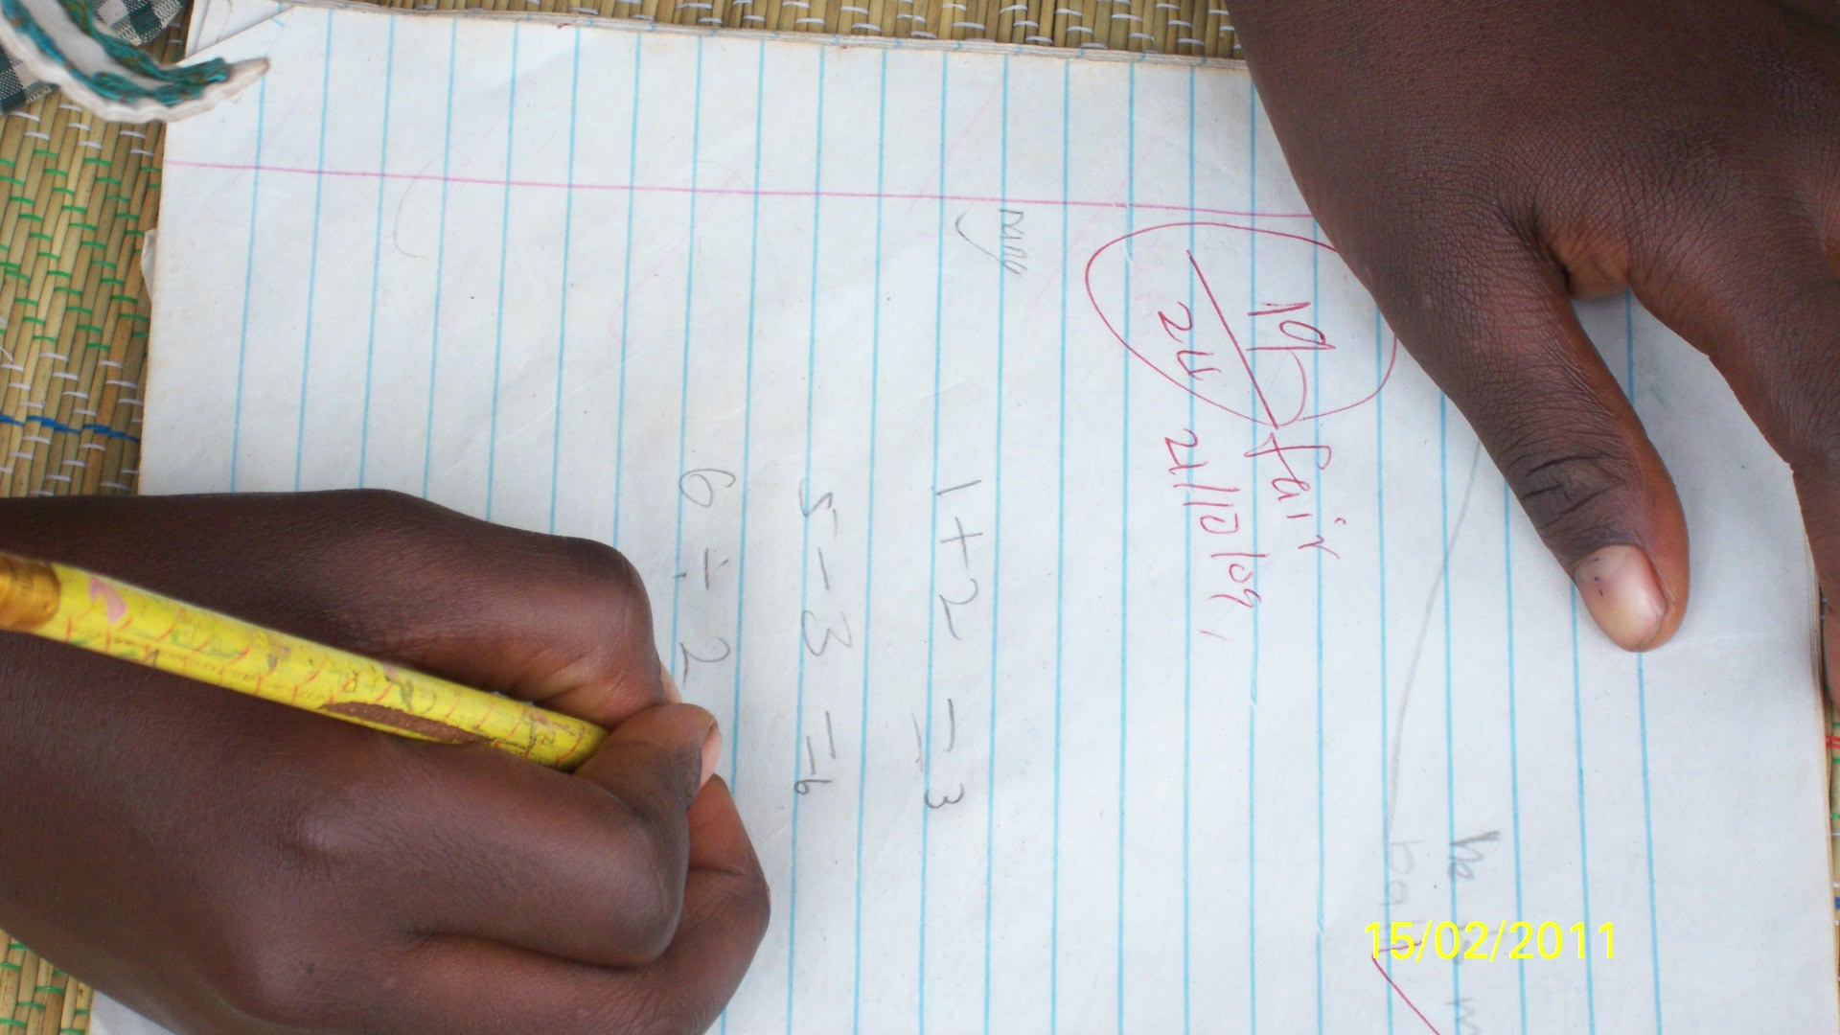
- Paying school fees
- Buying scholastic materials,
- Buying school uniform(s)
- Buying shoes and stocks and any other material(s) you may think fit for the furtherance of a child’s education.

What do I get as a child sponsor?
- Clemency Uganda will provide you with a photograph of your sponsored child, family, home and school.
- We will provide you with an update about his/her progress and improvements at school.
- We provide the child an opportunity to send you drawings and write to you as their English improves but we do not force.
- You are also entitled to a telephone conversation with your sponsored child five times a year. However, if you wish to have a telephone conversation with your sponsored child at anytime of the year, this is o.k. for as long as you make pre-arrangements with Clemency Uganda.
- You will be entitled to visit a child at anytime of the year. Please contact Dr. Mwiima Gerald at coordinator@clemency-uganda.org to make logistical arrangements.
- You will be provided with a receipt for every monthly or whatever donation made.
- You will receive an annual report from Clemency Uganda
- You will also have the satisfaction that you are helping a child to realize his/her potential.
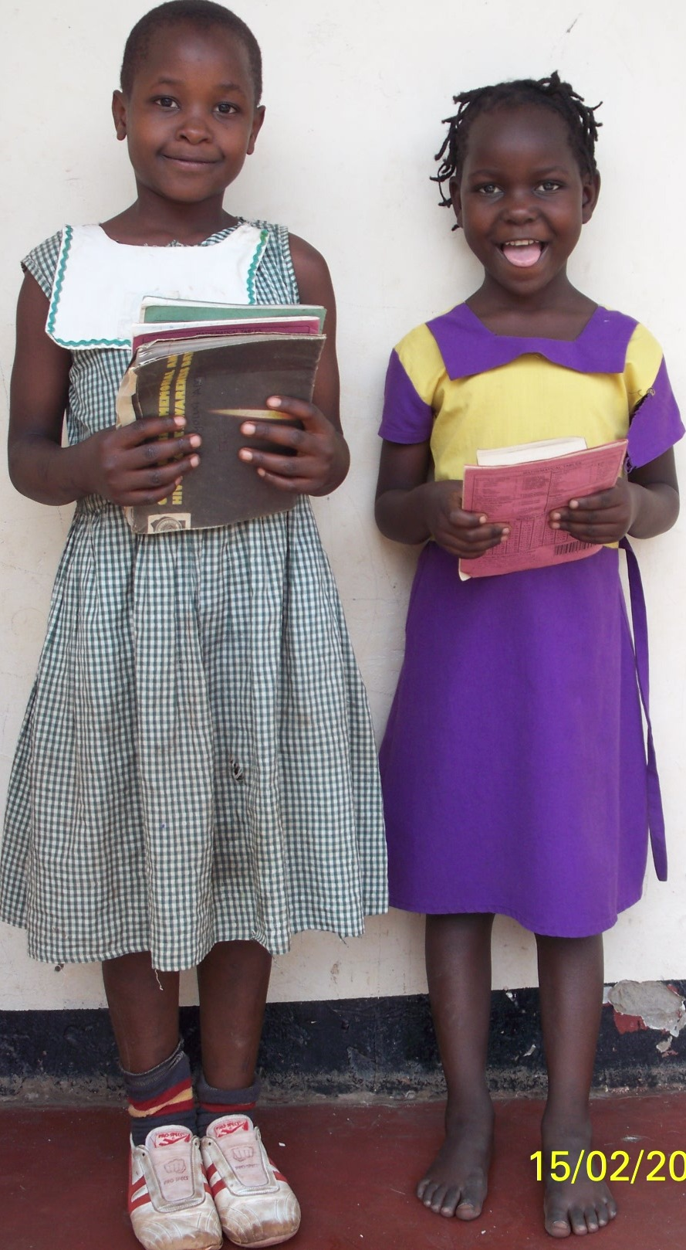
What will my donation do?
Your donation will go a long way in meeting the child’s school expenses i.e. school fees, pens, pencils, mathematical sets, exercise books, uniforms, shoes, stocks, clothing and beddings and lunch so that the child can concentrate better in class.

Sponsorship Notes
I would like to sponsor a child

First Name: Second Name:

Address: Nationality:

Telephone: Email:

I would like to sponsor (no. of children) on a monthly/quarterly/or annual basis starting

With (USD, Euros, Shs)

Sign: Date;
We will keep your personal information confidential. You will hear from us about the child/ children you are sponsoring and our sponsorship scheme.

Your monthly sponsorship funds can be transferred to Clemency Uganda Bank account as detailed below
Name of Bank: Post Bank Uganda. Bank address: Jinja. City and Country: Jinja, Uganda
Account Number: 2121100000134
Beneficiary: Clemency Uganda. Swift Code: UGPBUGKA
Take a step,bring hope to child

